RMFit Windows Installation Instructions:

- Unpack the rmfit tar file to your computer (the location should not matter). A convenient location is directly on the C drive resulting in C:\rmfit. You should avoid paths with blank spaces in names: i.e.: “Files and Folders”. It should be noted that the functions IDL uses to find files do not like the Desktop, as that is referenced from a directory with spaces in the name.

- Copy the 4 files (libifcoremd.dll, libmmd.dll, mfit.dll, and mfit.dlm) from the rmfit\mfit\MicrosoftFiles folder into the bin.x86 directory in the RSI folder. If you did not change the defaults while installing IDL, the directory is c:\RSI\IDL61\bin\bin.x86, where ID61 represents IDL version 6.1 and could be different, depending upon whichever version of IDL is currently installed. In the following, we continue to assume IDL 6.1; the procedure is very much the same for later version; 7.0 is current as of this writing. rmfit runs well from version 6.1 and upwards.

- Start IDL.

- For Users With Just the Virtual Machine (a non-licensed version of IDL): If you have just installed the virtual machine for IDL, Select “IDL” from the “RSI IDL Virtual Machine 6.1” Program Group after clicking the Start button at the lower left hand corner of the screen. This will start the demo version of the IDL program that will run for 7 minutes. This is needed to set one path variable (7 minutes should be plenty of time!).
- For Users With a Full Version of IDL (a licensed version): If you have a full IDL install, just start IDL (usually by selecting “IDL” from the “RSI IDL 6.1” program group obtained after clicking the Start Button at the lower left hand corner of the screen). The instructions to follow are the same for the demo version and the fully licensed versions of IDL.

- Within IDL, select the “File” menu item at the top left of the IDL window.

- Then, after selecting “File” select “Preferences…”.

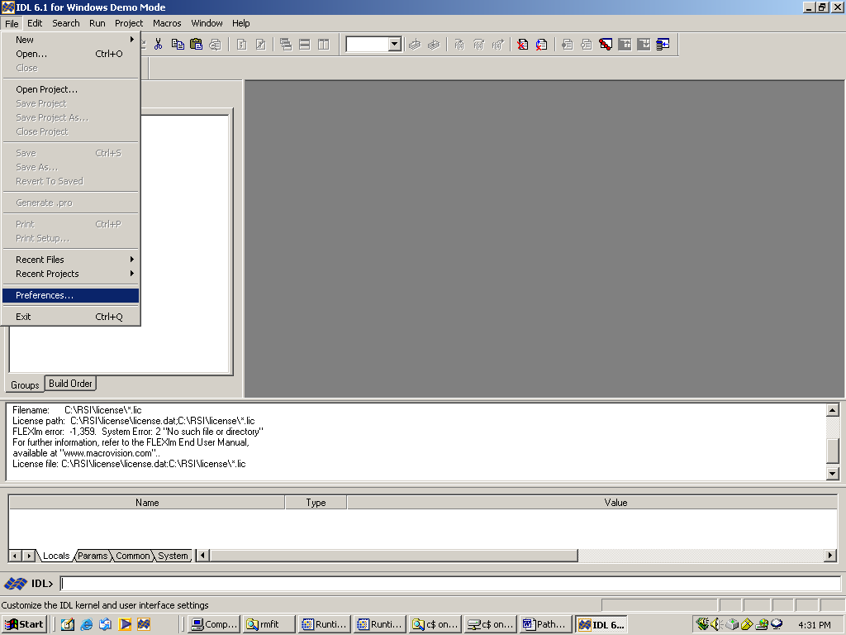

- You should now see the following popup:

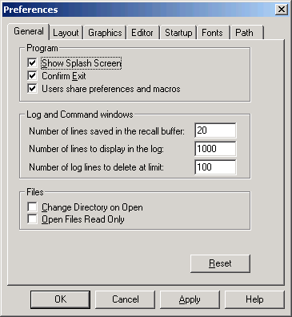

- Choose the “Path” tab at the far right. If you have not added any folders to the path, you should have something like the following. (However, if you have previously added path information, it will appear in the pane along with <IDL_DEFAULT>.)

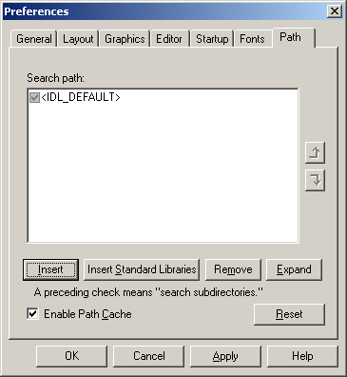

- Click the “Insert” button and you will be given a window to browse for the folder you wish to insert into the path.

- Select the folder location where you put the rmfit folder from the CD and click the “OK” button You should now have something similar to the following (if you had not previously added folder locations to the path). If you had copied the rmfit folder, directly to the C: drive of your computer, your screen should look like the following:

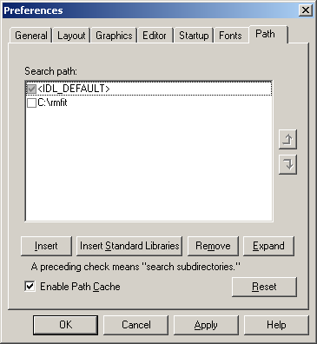

- Click “OK” in the remaining “Preferences” window.

- You can now exit out of IDL

- To run the rmfit code, either start the IDL Virtual Machine (there is a probably an Icon on your desktop) and when it prompts for a save file, choose rmfit from the rmfit folder or else start IDL itself (if you have a license) and type, ‘rmfit’, on the command line.

- There are more details about running rmfit in the Help menu of the program itself. Some of the displays have their own sets of help files, so if something doesn’t look familiar, read the help topic about the specific command.

